First
Aid
For
Research
in
of books, magazines, e-resources, …

- Limo: what?

Limo is the central search interface that researchers and students, affiliated with the KU Leuven Association, can use to research various scientific information sources in one search.
The information sources, which partly overlap, are the following:
      - The LIBISnet catalogue: the catalogues of all libraries in the KU Leuven Association and other LIBISnet partners.
      - LIRIAS: contains publications of KU Leuven’s own researchers and its Association partners.
      - Articles and e-books from databases

- Limo: where?

- Go to www.ucll.be/libraries

- On the library page, enter your search-term into the search-box or click on the Limo link:
OR: Go to limo.libis.be/ucll

- Limo: how?

3.1 Log in

- Change the language to English through the menu
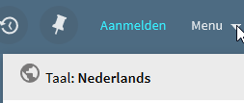

- Sign in
Click on the ‘sign in’ button, on the upper right corner.

- Click on the ‘Central Login for students and Staff Associatie KU Leuven’ button.

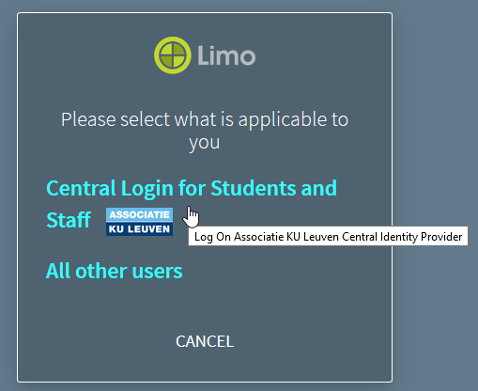

- Enter your username and password.
See your UCLL card for an r-, s-, c- or u- number.

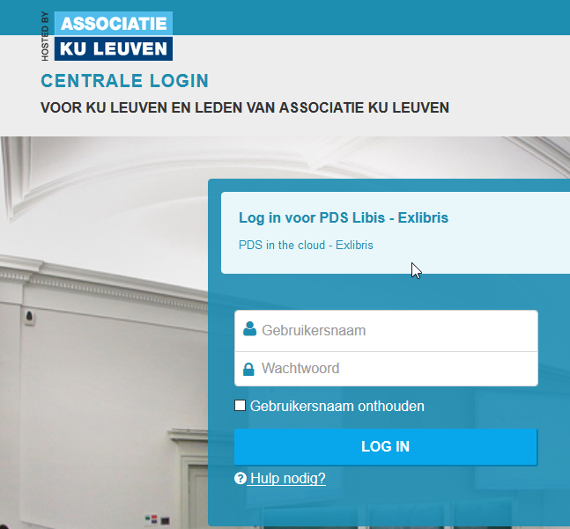

3.1.1 My account

Click on your name, on the upper right corner, to open the shortcut menu. Through this, you can get an overview of:
- Your Library Account,
- Your Loans,
- Your Requests,
- Your saved items,
- Your search history,
- Display Language: set to English once more so it will be saved as your default language.
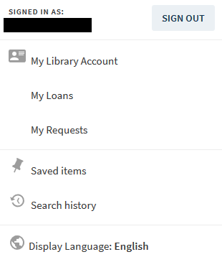

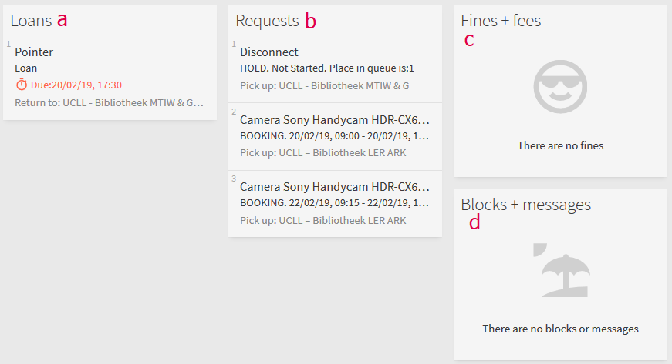
Your library account gives you an overview of:
- Your loans, with a button to renew all your loans at once,
- Your enquiries,
- Your fines and expenses,
- Your blocking and messages.

- “Loans” gives you a complete overview of your active loans, as well as your previous loans.

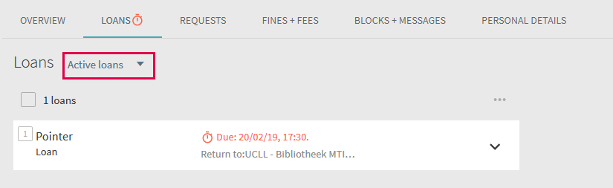

The loan period of your active loans can be extended by pressing the button or the button.

- When you click on ‘Request’, it gives you an overview of all the reservations you currently have and your place in the queue. When the item requested is available, you will automatically receive a notification by email. If you no longer need if, you can cancel your reservation.
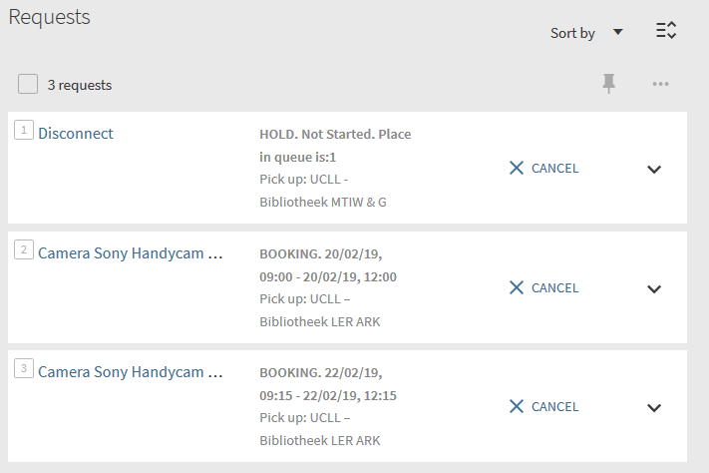

- ‘Fines + fees’ gives you an overview of your outstanding balance. Fines are charged for items that are returned late (it is 0,10 € per items per overdue day).
Costs include requesting an item from another library and administration / invoicing costs in the event of non-collection.
Fines and charges must be paid in the location where the fine or fee was charged.
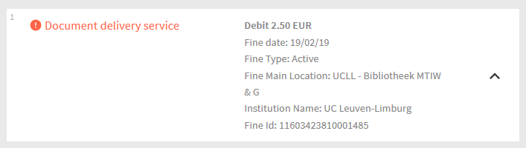

- Blocking and Messages
If you are blocked, you can find the nature and reason for this blocking here.
A blocking can be LOCAL or GLOBAL.
LOCAL: you have a blocking within UCLL,
GLOBAL: your blocking applies to all libraries within the KU Leuven Association.
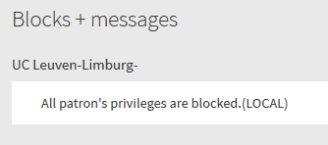

3.2 Defining the search terms

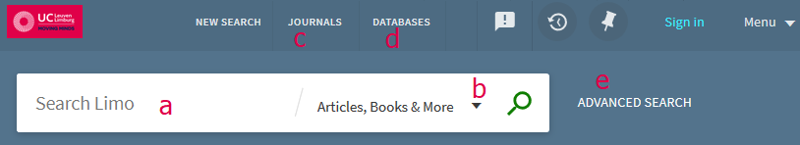
- Search field: enter your search term(s) here. For better results or specific searches, you can use:
- Boolean operators (combining search terms)
- AND
searches for texts containing term 1 AND term 2
- OR
searches for texts containing term 1 OR term 2
- NOT
searches for texts in which term 1 is and term 2 is not.
- Wildcards: searches for part of the word
- ? different words with one letter difference
        - Wom?n: in the result, you will find both woman and women
- * leave several characters open
        - ball*: in the result, you will find balls, balloon, balloons, …
        - *ient: in the result, you will find patient, gradient, …
        - Alumi*m: the result begins with alumi and end with m : aluminium, aluminum
- # different spellings where they can be one more or one less letter
        - colo#r: in the result, you will find both colour and color
        - arch#eology: in the result, you will find both
archaeology and archeology
- Certain punctuation marks :
- Brackets ( and ): to group terms
        - Shakespeare AND (tragedy OR sonnet) :
in the result, you will find Shakespeare in combination with either tragedy or sonnet.
- Quotes “” : to search for exact word combinations or terms
        - “global warming”: in the search results, you will never see the terms warming and global separately.

- Define the search location

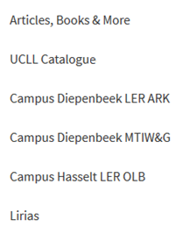

- Articles, Books & more
Using this way, you can search through both the physical and electronic collection of all libraries within the KU Leuven Association.

- UCLL Catalogue
You can search through both the physical and electronic collections of all UCLL Libraries (both Leuven and Limburg).

- Sublibraries
You can search through both the physical and electronic collection of the UCLL library associated with your study program.

- Search articles in a particular journal. You can search the journals using the title or the ISSN.

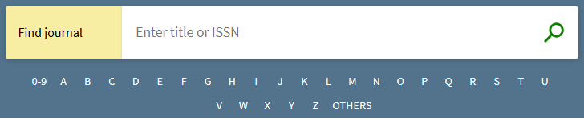

- Search via databases
Find the right link to a database. You can search the databases by name. Some of these databases can also be searched through a Limo search.

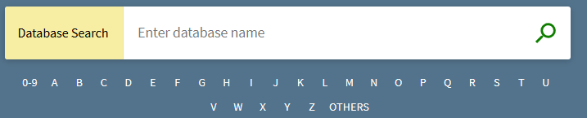

The core range of all databases to which UCLL is subscribed can also be found detailed at www.ucll.be/bibliotheken > Digitale Bibliotheek (Dutch only)
- Advanced Search
Through advanced search, you can search by title, author, subject, ISBN / ISSN, publication date, source type, etc. If you are signed in in Limo, you will be able to access more full-texted sources. It will not be the case if you are not signed in.

- Search results based on Articles, books and more

4.1 Refine search results
You can tweak your search results in all kinds of ways.

  - Expand (with sources that are not full-texted online)

  - Sort by relevance, title (A – Z) and date (latest < > oldest first)

  - You can also refine using…
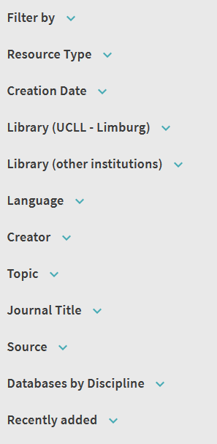
    - Filter: filtering physical copies, peer-reviewed and online access
    - Resource type: books, articles, textbooks, thesis, databases, etc.
(depending on your search)
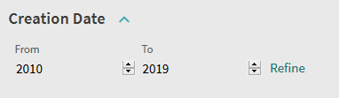
    - Refine the Creation Date:
by choosing the period (do not forget to click on the ‘Refine’ button).

    - Limit the results to the level of the Library.
This can be within UCLL or other institutions.
    - Continue Filtering by language, creator, topic, journal title or source.
The same search result can come from several databases.

4.2 Details of search results

When you click on a search result, you can see the details of that search. On the left is a bar that allows you to navigate to the details of the previous search result or return to the search result list.

The buttons on the top right corner of a search result allow you to “send” the data.
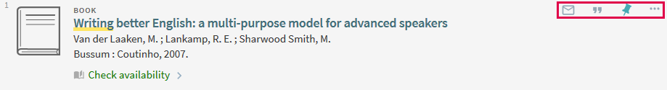

Sending includes exporting, printing, sharing, saving in Endnote or other source referencing software.
If you are signed in, you can also save the search results in “My Account” and consult it in “My saved items”.

4.1.1 Availability of the search result

- Multiple versions
If several versions of a source are available, the number of versions will be shown at the bottom of the search result.
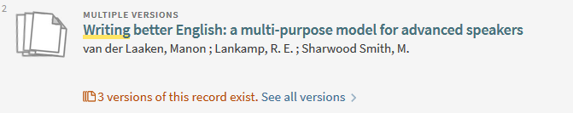
Click there to see which versions are available.

- Online availability

If it concerns an online source, the Online access will be indicated.

- Availability at locations inside and outside UCLL
If a copy is available both inside and outside UCLL, the search result will look like this:
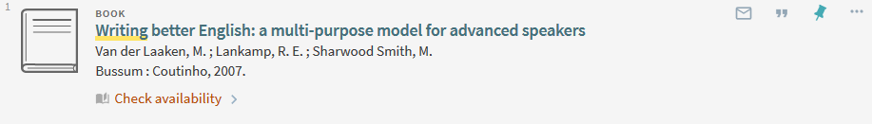
Check availabily indicates that the system cannot determine if the copy is available because there are multiple locations.

- Available in UCLL
Available in UCLL – it means that a copy is available in one UCLL library
If it is available in at least two libraries, multiple locations will be listed.
Click on Available at … to find out in which UCLL library(ies) a copy is available.

- Exact location of the copy requested
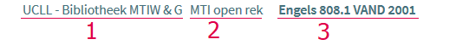

            - Name of the UCLL library
            - Name of the sub-collection where the item is located
There is often an open rek (open shelf) or balie (loan desk) there.
            - The location number of the item
This corresponds with the label on the back of the copy.

- Information concerning the copy

- Type: it is often a Copy, but can also be compact disk or other,
- Loan period: the standard loan period is 21 days for a student, but an adjusted loan period may also apply (for example: 1 day, 7 days, etc.)
- Description: it may contain additional information regarding the copy (for example: 7th edition, 2018 edition, etc.)
- Status: it displays whether the item is available and how many times the copy has been requested.

For further questions and comments, you can contact the lending desk of you library, or contact us via www.ucll.be/bibliotheken.

Good luck!

