DOCUMENTATION FOR ATTESTATION OF STUDENTS WITH A VISUAL IMPAIRMENT
The form below must be completed by the (treating) doctor. The document is returned to the (function and service) via the student. The data attested here will be processed and treated in accordance with the Belgian and European privacy legislation and in accordance with the provisions in the education and examination regulations of the institution.

EXPLANATION
- General
The [name of the institution of higher education] is responsible for the recognition, the advising of specific facilities and the assistance of students with a disability at [name of the institution of higher education]. The student's disability must be documented for the following reasons:
- The student is required to confirm his disability with sufficient, objective and clear medical documentation to obtain recognition as a student with a disability.
- To be able to offer accommodations as an institution, it is important to have as good as possible an overview of the student’s particular difficulties and their impact on his/her school performance. This overview offers a base for the assessment, with the difficulties measured against the program requirements and against the feasibility of reasonable adjustments in the faculty.

- Target groups and qualified experts for the documentation
The documentation is to be completed by a qualified expert determined per target group. Please find an overview of the target groups and the corresponding qualified experts below.
Target group | Qualified expert
Students with a physical disability | (Treating) doctor
Students with a hearing impairment | (Treating) doctor
Students with a visual impairment | (Treating) doctor
Students with a chronic disease | (Treating) doctor
Students with a developmental disorder | (Treating) doctor), (child and youth) psychiatrist, neurologist, neuropediatrician, certified psychologist or registered orthopedagogue, speech therapist; depending on subtype (see further general part: overview of specific attestation bundles)
Students with a psychiatric disability | (Treating) doctor), (child and youth) psychiatrist, certified psychologist or registered orthopedagogue
Students with another disability | (Treating) doctor

- Documentation for attestation
We kindly request that you as a competent expert thoroughly document and objectify the student’s loss of function.
You can do this using this documentation, which comprises the following parts:
General part (Part 1)
This is where you may indicate which loss of function the student is showing. The nature of the disability determines the target group to which the student belongs.
The Vlor-form for a specific target group (Part 2)
You are required to complete section A and section B.
Section A deals with the nature, severity and duration of the loss of function. The request to attest does not imply that the authorized person must carry out a diagnostic examination in any case. It is also possible to attest after viewing the reports that the student makes available.
Section B maps the loss of function and its impact on school activities.
Both parts are to be completed by the qualified expert for that particular target group. The student will be in charge of returning both documents to the [function and service].
- Privacy
The medical documentation (part 1 and part 2) is kept in the student’s file by the [function person]. The data attested here will be processed and treated in accordance with the Belgian and European privacy legislation and in accordance with the provisions in the education and examination regulations of the institution.
- Contact
You may contact the [function and service] should you still have questions. His/her contact details can be consulted through the following link: [www]

GENERAL PART (PART 1)
The documentation comprises two parts. In this general part (part 1), the nature of the loss of function is to be indicated. The overview of the included functions is based on the International Classification of Functioning, Disability and Health (ICF). The nature of the disability determines the target group to which the student belongs. With a view to further documentation, the decision tree is to be followed and the Vlor+ form for the specific target group is to be completed (part 2).
The following forms are available for specific target groups:
Documentation for attestation | Qualified expert
Students with a physical disability | (Treating) doctor
Students with a hearing impairment | (Treating) doctor
Students with a visual impairment | (Treating) doctor
Students with a chronic disease | (Treating) doctor
Students with an autism spectrum disorder (ASD) | (Treating) doctor, (child and youth) psychiatrist, neuropediatrician, certified psychologist or registered orthopedagogue
Students with an attention deficit hyperactivity disorder | (Treating) doctor, (child and youth) psychiatrist, neurologist, neuropediatrician, certified psychologist or registered orthopedagogue
Students with a tic disorder | (Treating) doctor, (child and youth) psychiatrist, neurologist, neuropediatrician
Students with a developmental coordination disorder | (Treating) doctor, neurologist, neuropediatrician, (child and youth) psychiatrist
Students with a stuttering disorder (developmental stuttering) | (Treating) doctor, speech therapist
Students with developmental dysphasia | (Treating) doctor, speech therapist
Students with a psychiatric disability | (Treating) doctor, (child and youth) psychiatrist, certified psychologist or registered orthopedagogue
Students with another disability | (Treating) doctor
If so desired, the student can request the documentation for an additional target group from us or download it on [www].

STUDENT’S IDENTIFICATION INFORMATION
Student’s name:
Date of birth:
Student number:

IDENTIFICATION INFORMATION OF THE EXPERT
Name:
Date:
Autograph:
Doctor’s stamp

RECORD DATA (to be completed by the [function])
Study/Faculty/Campus:
Receipt date of complete file:

Nature of the loss of function
The qualified expert documents that the student presents the following loss of function:
□ Single disability, in one of the following body functions:
□ Neuromusculoskeletal and movement-related functions
The documentation for students with physical disabilities target group is to additionally be completed if the disability does not result from a chronic disease, psychiatric disability or developmental disorder.
□ Hearing functions
The documentation for students with hearing impairment target group is to additionally be completed if the disability does not result from a chronic disease or psychiatric disability.
□ Visual functions
The documentation for students with visual impairment target group is to additionally be completed if the disability does not result from a chronic disease or psychiatric disability
□ Cardiovascular, haematological, immunological and respiratory functions
□ Digestive, metabolic and endocrine system
□ Genitourinary and reproductive functions
The documentation for students with a chronic disease target group is to additionally be completed if the disability does result from a chronic disease.
The documentation for students with another disability target group is to additionally be completed if the disability does not result from a chronic disease or psychiatric disability.
□ Mental functions
The documentation for students with a chronic disease target group is to additionally be completed if the disability does result from a chronic disease.
The documentation for students with a developmental disorder target group is to additionally be completed if the disability does result from a developmental disorder.
The documentation for students with a psychiatric disability target group is to additionally be completed if the disability does result from a psychiatric disability.
The documentation for students with another disability target group is to additionally be completed if the disability does not result from a chronic disease, psychiatric disability or developmental disorder.
□ Other:
□ Voice and speech functions
□ Pain functions
□ Skin and related systems functions
The documentation for students with another disability target group is to additionally be completed if the disability does not result from a chronic disease, psychiatric disability or developmental disorder.
□ Single disability, the loss of function results from a chronic disease:
The documentation for students with a chronic disease target group is to be completed.
□ Single disability, the loss of function is connected to a psychiatric disability:
The documentation for students with a psychiatric disability target group is to be completed.
□ Multiple disabilities:
If there is a multiple loss of function, the corresponding form for the specific target group is to be completed for each disability.

VLOR-FORM (PART 2)

STUDENTS WITH A VISUAL IMPAIRMENT
The form below must be completed by the (treating) doctor. The document is returned to the (function and service) via the student. The data attested here will be processed and treated in accordance with the Belgian and European privacy legislation and in accordance with the provisions in the education and examination regulations of the institution.
To assist students as efficiently as possible, we would like to underline the following areas of attention in completion of this form.
- The form is to be completed entirely, objectively and meticulously.
- The form is to be completed by the qualified expert.
- Both section A and section B are to include the date, the signature and the identification (stamp) of the qualified expert.

We cannot accept documents that fail to meet these requirements.

STUDENT’S IDENTIFICATION INFORMATION
Student’s name:
Date of birth:
Student number:

SECTION A
LOSS OF FUNCTION

- Nature of the loss of function
I, the undersigned, document that the person identified above shows the below indicated hearing losses of function:
0 Visual acuity
- Corrected visual acuity
- Right eye
- Left eye

0 Field of vision
Goldmann perimet chart
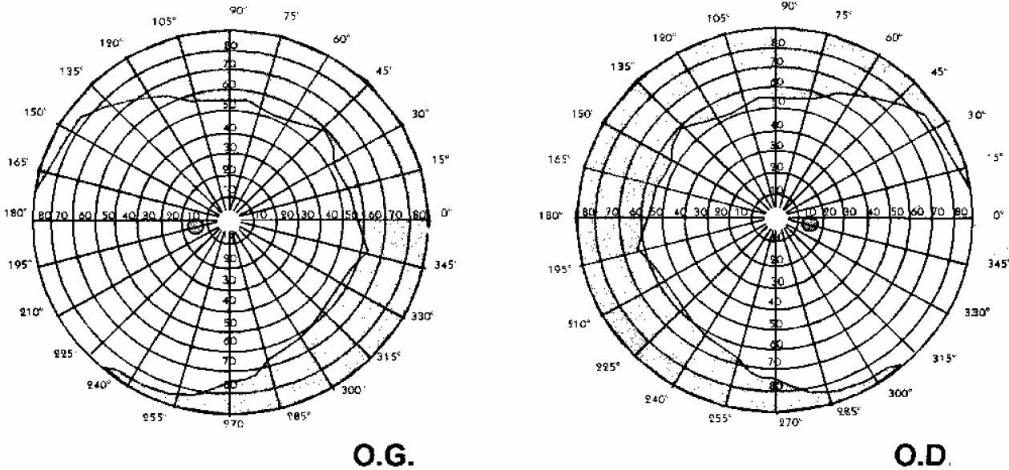

0 Quality of vision: light sensitivity, colour vision, contrast sensitivity, visual image quality (specify)

0 Other: ……………….

This loss of function results from: ……………………..

- Registration requirements
Following the above, I confirm that this person a visual disorder that meets at least one of the following criteria:
0 (1) a corrected field of vision smaller than or equal to 3/10 for the best eye;
0 (2) one or more field of vision defects that take up more than 50% of the central zone of 30% or that concentrically reduce the field of vision to less than 20%;
0 (3) a complete altitudinal hemianopia, an ophthalmoplegia, an oculomotor apraxia or an oscillopsia (subjective instability of the field of vision);
0 (4) a serious visual disorder (such as: visual agnosia, neglect of a body half, lack of discrimination of figure/background, …) which stems from an objectified cerebral pathology (CVI);
0 (5) a visual condition, objectified by undersigned (treating) doctor and described in point 1 (nature of the loss of function), which cannot be reduced to the criteria (1) through (4), but of which the impact on the school performance is obvious and documented in section B of this form by undersigned doctor.

I hereby also confirm that:
0 the disorder and the loss of function are permanent: there is a non-existent or negligible chance of improvement (spontaneous or following treatment) that would lead the loss of function to no longer meet the conditions described above.
0 the disorder and the loss of function is (likely) of a temporary nature: there is an effective or expected loss of function, or a need for a preventive follow-up of at least 12 months, with an impact on school performance.

- Stamp, date and signature of (treating) doctor

Date Stamp

Signature

STUDENT’S IDENTIFICATION INFORMATION
Student’s name:
Date of birth:
Student number:

SECTION B
IMPACT ON SCHOOL PERFORMANCE

I hereby document that, following a serious visual impairment described in section A of this form, the student identified above experiences difficulties in performing the following school activities:
- Communication and information exchanges
- Observing, from a distance (e.g. what is written on the blackboard, PowerPoint presentations, clips and footage etc.).
Difficulties:

- Reading (course materials, messages on the notice boards, etc.), incl. tiredness after continued reading.
Difficulties:

- Writing (when taking notes during classes, writing on the blackboard), incl. readability of the handwriting, writing speed, writing duration and tiredness from writing, meticulously (minutely) working when making drawings, working with graphs, etc.
Difficulties:

- Mobility
- Moving around (e.g. from student accommodation to classroom, from one building to the next, inside a building, moving around with public transportation), incl. the ability to read classroom signs.
Difficulties:

- Wielding material, incl. eye-hand coordination (e.g. use of a calculator).
Difficulties:

- Other
- Possible impact of general tiredness and/or available energy and/or treatment on the ability to attend classes, to study,…
Difficulties:

- Stamp, date and signature of the (treating) doctor

Date Stamp

Signature

The procedure followed at [name of the institution of higher education] is based on the method recommended by the Vlor (Vlaamse Onderwijsraad – Flemish Education Council]: ‘Handleiding registratie studenten met een functiebeperking en bijbehorende formulieren’, Raad Hoger Onderwijs, 21 april 2015.

